Paper-Cup Planetarium Instructions

This activity shows guests how to make a simple pinhole constellation projector from a paper cup. Materials are 5-oz. paper drinking cups, pre-printed constellation pictures, a push-pin, and a Glue-Stick™. Optional materials include a bright, single-LED flashlight and a 1⅝"-diameter piece of firm cushioning (like polyethylene foam) to make hole-punching easier and prevent the cup that's being punched from collapsing (in case the push-pin is too blunt to poke through easily).

Select a constellation from the pre-printed sheet. The materials described use 1-⅝" circular images which fit the end of a 5-oz Dixie™ paper cup. The star patterns are some of the more recognizable asterisms (Dippers, Great Square, Teapot, etc.)—as opposed to, say, Canis Minor, which is two exciting dots...or Triangulum, which is (amazingly-enough) three dots. Hevelius interpretations are overlaid on the star patterns.

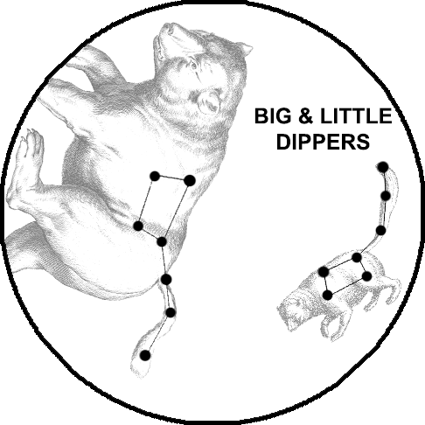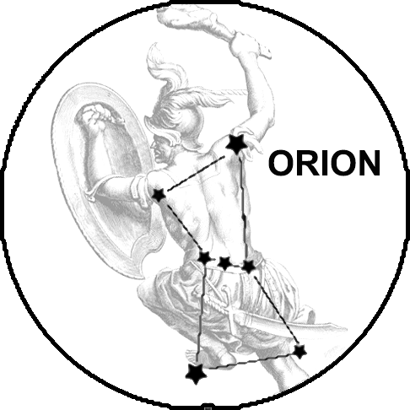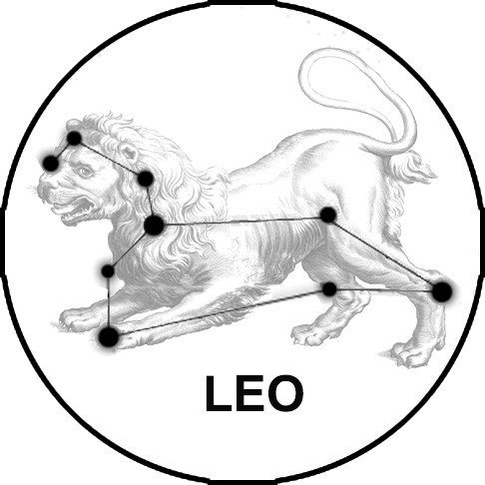
The constellation art can be pre-cut or cut during the activity (though that may take too much time). With the Glue-Stick, apply glue to the outside bottom of the paper cup, and press the constellation to it so the artwork is showing. Put the optional support cushion onto the end of another cup and nest the constellation cup on top of it, with the cushion sandwiched between them. Using the push-pin, carefully poke holes in each star of the constellation art. The cup is now done!
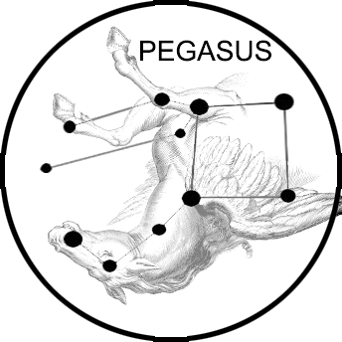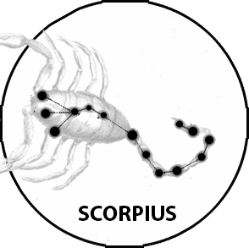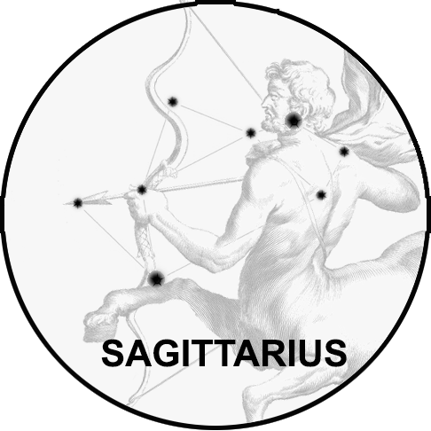
As can be seen from the artwork, the constellations are printed backward, but look from inside the cup, and they will look as they should. On a sunny day, the open end of the cup can be pointed toward the Sun to project the constellation down into the shadow of the cup itself . Also, holding a flashlight inside the cup, you can project the constellation in a dark room—the single-LED avoids multiple images.

